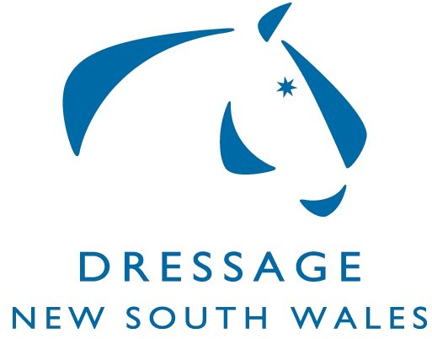
Funding Support for Officials

Equestrian NSW has allocated funding to Dressage NSW for support of officials to gain/update/maintain their Officials status.

Officials who incur expenses to attain accreditation, upgrade their accreditation or attend courses to retain their official status may apply to Dressage NSW for funding.

Some examples of applications that may be considered for funding are below. NOTE: this is an example only and the funding is not restricted to Judges, other officials may apply.

- Judges attending Seminar for upgrading purposes for re-accreditation purposes;
- Judges travel and other related expenses for judges sitting exams;
- Judge Educators attending updating courses or other EA organized seminars relating to Judge Educators;
- FEI officials attending a course such as FEI Stewards course.
- Other officials attending refresher courses to maintain accreditation

The support is available only to Equestrian Australia accredited NSW officials. Funding will be considered for Judges who are embarking on a judging career and who need to travel to attend a Seminar or do Shadow Judging or Exams.

- Each application will be considered on merit however it may not be possible to support each and every application as we have a limit of funds available.
- Seminars take precedence over Workshops and only one workshop or Seminar will be considered in each accreditation cycle.
- Metro Judges can claim only once for reimbursement to attend a Seminar in
each accreditation cycle. Metro judges may not claim workshops held within the metro region.
- Travel reimbursement claims for trips of less than100km (one way) may not be considered depending on available funds.
- In general terms, an official may claim a maximum of $300 per accreditation cycle. In exceptional circumstances the Committee may approve a higher amount.
- There is an annual limit of funds available and claims will be considered in order of receipt.

To apply for funding, please complete the attached application form on the next page and return to Dressage NSW.

Funding generally is not paid until after the course/activity has taken place unless by arrangement.

Application Form - Funding Support for Officials

Name of Official:
Official type (Judge, Steward etc) and current
status:
Tel: | E-mail:
Address:

Please provide details on the reasons for applying for funding, including the Seminar/clinic or other activity you are seeking reimbursement for, how this fits into your schedule for reaccreditation or upgrading your official status, the date, location, the amount of subsidy you are seeking and details on what these funds will be used for (eg. travel, accommodation etc). Funding generally is not paid until after the activity has taken place, unless by arrangement. A maximum amount of $300 may be claimed per accreditation cycle unless otherwise approved. Please keep a record of what you have claimed.
Please read the guidelines before applying.

Type of Activity:
Date:
Location
Amount of Funding requested | $
Bank details: BSB: Account no:
Name of Account:
Details on what the funding will be used for: *

* Attach a note if a space does not allow for all details.
Return this Form to: Dressage NSW, PO Box 372, RICHMOND, NSW, 2753 E-MAIL: admin@dressagensw.com.au

