Affiliated Club Application Form for Judges Seminar Funding
Dressage NSW has obtained Funding to assist with the education of Officials through Equestrian NSW.
Applications are called for from Clubs in regional areas who would like to conduct a Seminar in 2016 calendar year.
Seminars in the Metro area are usually conducted by DNSW however Metro Clubs wishing to hold a Seminar may apply for support.
The amount of funding available will depend on the budget supplied. In all situations the Judge Educator Fee and where possible the JE travel will be covered by DNSW.
Funding guidelines: Approx $500 - $1,000 per Seminar available. Funding above this amount will be considered depending on the budget supplied.
Recognition of the support from DNSW & ENSW for funding Seminars must be acknowledged.
Clubs can now apply for funding for seminars (application form attached). The JSC will review the applications and put forward recommendations to the Committee of DNSW. The Committee of DNSW will make the final approval of funds allocated for this purpose.
Once approved, Dressage NSW will forward funds to the successful club, in line with the budget submitted. If funds are available after allocating funds for each Seminar, the balance of the funds will be distributed to Clubs based on the budget submitted with the application.
Following the seminar a report must be submitted to The Secretary, Dressage NSW Inc. This report will be forward to Equestrian NSW as part of DNSW’s overall report on the acquittal of the funds.
Note: The Application Form must be received no later than three (3) months before the date of workshop/seminar to enable the Committee time to consider applications. Applications may be considered outside this time frame in exceptional circumstances.
There is a limit on the funding available and not all applications may be approved.

The intention is that these seminars be free to all judges and for people wishing to become judges.

Definitions:
Judges Seminar (Refer EA Dressage Rule Book Section 9 ) Seminars provide the only opportunity for reaccreditation (every three years) and upgrading. Seminars provide the platform for discussion between judges to find a standard. An EA seminar can only be conducted by approved Judge Educators.

An Application form for funding is on the next page.
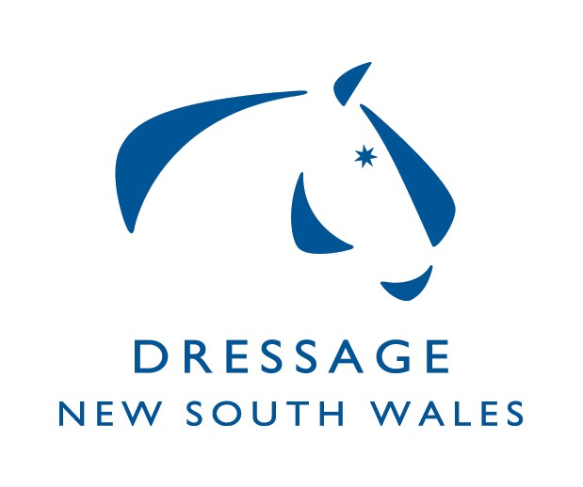
Affiliated Club Application Form for Seminar Funding

Club Name:
Contact:
Address:
Phone: | Email:

Seminar Details
Date of Seminar:
Judge Educator requested:
Level of Seminar:
Estimated number of participants: | Judges: Spectators
Other details:
(including whether a fee will be charged for participants)

Exams: Please provide information if your Clubs wish to be considered for holding exams and can fulfill requirements as per Section 9 of the rule book. The approval to run Exams will be considered if Candidates have applied to upgrade and have completed their Pre Requisites.

Seminar Budget
Judge Educator Fees | $
Travel and Accommodation for JE | $
Hire of facility & catering | $
Hire of equipment | $
Other (give details) | $
Total Expenditure | $
Minus - income if any (charges for participants or other) | - $
Total estimate cost of Seminar | $

Send application form to: Dressage NSW, Judges Sub Committee
PO Box 372, Richmond, NSW, 2753

